EXECUTIVE SUMMARY

RESETTLEMENT ACTION PLAN

For
Rongjeng–Mangsang–Adokgre (RMA) Road-ko 23rd km pora 44th km bilsi improvement ka·se, Eldek Akong-o major bridge aro Bridge No. 1/6 construction ka·san, Meghalaya Logistics and Connectivity Improvement Project (MLCIP) rang·san, World Bank fund ka·se.

Submitted To

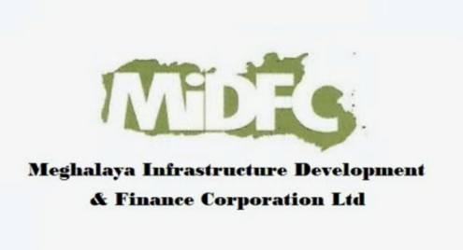

Meghalaya Infrastructure Development Finance Corporation (MIDFC) Ltd.
House No. L/A-56, Lower Nongrim Hills, Top Floor,
Meghalaya Basin Development Authority (MBDA) Building,
Shillong East Khasi Hills, Meghalaya-793003

EXECUTIVE SUMMARY

1. Project Background

Meghalaya Logistics and Connectivity Improvement Project (MLCIP), World Bank fund ka·e aro Government of Meghalaya support ka·e, regional connectivity-ko neng·ketna, logistics efficiency-ko improve ka·na, aro climate-resilient transport infrastructure-ko promote ka·na aim ka·a. Proposed sub-project-o Rongjeng–Mangsang–Adokgre (RMA) Road-ko km 23+000 pora 44+000 (total 22 km) bilsi improvement ka·a, Eldek Akong-o major bridge aro Bridge No. 1/6 construction ka·san. Road-o East aro North Garo Hills District-rang bilsi ong·a aro rural shnong-rang, market-rang aro service centre-rang-na bynta important regional connector ong·a.

2. Need for the Resettlement Action Plan
RAP-ko road widening aro related civil works rang·san Corridor of Impact (CoI)-o ong·a land, structure aro livelihood impact-rang-ko address ka·na bynta prepare ka·a. Project-o Sixth Schedule area-o ong·a jaha Scheduled Tribe community-rang dominate ka·a, uni RAP-o World Bank Environmental and Social Framework (ESF), national aro state regulation-rang-ko comply ka·a aro Free, Prior and Informed Consent (FPIC) integrate ka·e indigenous people-rang-ni right aro livelihood-ko safeguard ka·na bynta.

3. Project Impacts and Affected Population
Project-ni impact-rang limited aro localized ong·a, badi-batde existing Right of Way (RoW)-o ong·a. Impact-rang-o residential aro commercial structure-rang-ni partial loss, chhota asset-rang-ni loss aro kichu location-o common property resource-rang-o impact include ka·a. Project Affected Persons (PAPs) pilak Scheduled Tribe community, badi-batde Garo household-rang ong·a. RAP-o CoI bilsi affected household-rang-ni 100% census aro socio-economic survey cover ka·a, impact-rang-ni proper identification aro mitigation ensure ka·na bynta.

4. Socio-Economic Profile
Project corridor-o 13 rural village bilsi ong·a jaha Scheduled Tribe population badi-batde ong·a. Livelihood-rang-o agriculture, daily wage labour, petty trade aro forest-based activity-rang-na depend ka·a. Literacy aro income level village-rang bilsi vary ka·a aro vulnerable group-rang, jeman women-headed household aro low-income family-rang, noticeable ong·a. Social structure-o customary land tenure system aro matrilineal tradition-rang (Garo community-o) bilsi influence ka·a.

5. Consultation, Disclosure, and FPIC
Project planning time-o village aro district level-o extensive stakeholder consultation conduct ka·a. FPIC-ni tin round consultation PAPs, Nokma (village head), GHADC representative, aro local institution-rang baksa conduct ka·a—project information disclose ka·na, impact assess ka·na aro community consent obtain ka·na bynta. Consultation-rang-o culturally appropriate tarike-o, local language-o conduct ka·a aro feedback-rang project design aro mitigation measure-rang-o incorporate ka·a. RAP disclosure implementation time-o batabo continue ka·na.

6. Eligibility and Entitlements
Compensation aro assistance-na bynta eligibility-o CoI-o impact-o based ka·a aro titleholder, non-titleholder (encroacher aro squatter), aro vulnerable household-rang include ka·a. Entitlement-rang MPWD-ni approved Entitlement Matrix-o define ka·a, jaha RFCTLARR Act, 2013 aro World Bank ESF-sang aligned ong·a. Compensation-o full replacement cost-o provide ka·a, baksa resettlement assistance, livelihood restoration support aro Grievance Redress Mechanism (GRM)-o access ensure ka·a, jate affected household-rang-ni living standard restore ba improve ka·na man·a.

7. Institutional Arrangements and Grievance Redress
RAP implementation Meghalaya Public Works Department (PWD) ka·a, E&S Cell, district administration aro GHADC support-sang. Two-tier Grievance Redress Mechanism (GRM) establish ka·a jate complaint-rang transparent aro time-bound tarike-o address ka·na man·a, village, district aro state level-o accessible ong·a.

8. Implementation Schedule and Budget
RAP-o phased manner-o implement ka·na aro civil works-sang synchronize ka·a. Affected section-rang-o construction start-na skang compensation aro assistance pilak pay ka·na. Total Resettlement and Rehabilitation (R&R) budget estimate ka·a aro structure compensation, resettlement assistance, livelihood restoration, administrative cost, monitoring aro contingency-rang include ka·a.

9. Monitoring and Evaluation
RAP implementation effective ong·na ensure ka·na internal aro external monitoring mechanism use ka·a. Monitoring indicator-rang physical progress, financial disbursement, grievance redress aro livelihood restoration outcome-rang cover ka·a. Impact evaluation-o assess ka·a je affected household-rang nijer living standard restore ba improve ka·na man·e ni.

10. Grievance Redress Mechanism
Niche dia flowchart-o two-tier grievance redressal mechanism-ko explain ka·a, jaha responsibility aro resolution timeline-rang clearly define ka·a.

Tier I: Project Site Level | Responsibility: Village Executive Committees (VECs) aro Headman (Nokma)  Timeline: Grievance-rang 15 sngi-ni bilsi resolve ka·na  If unresolved → Escalate to PMU (Tier II)
Tier II: State Level (PMU) | Responsibility: Secretary Planning, Chief Engineer,  Project Director, Social Expert  Timeline: Grievance-rang 15 sngi-ni bilsi resolve ka·na

Grievance Redressal Mechanism
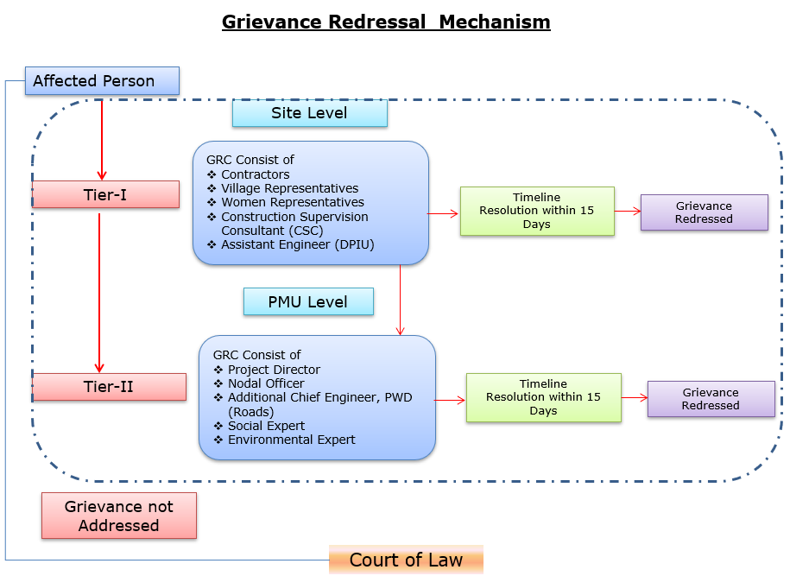

Details of contact for Grievances
Description | Contact details
Company: | PWD, Meghalaya
To: | Chief Engineer-cum-Nodal officer
Address: | HV9P+GFJ, Lachumiere, Shillong, Meghalaya 793001
E-mail: | esmlcip@gmail.com
Website: | http://megpwd.gov.in/contacts.html
Telephone: | Tel: 0364-3572466
Fax: | -

11. Conclusion
Rongjeng – Mangsang – Adokgre (RMA) Road-ni Resettlement Action Plan (RAP)-a project-ni inclusive development, tribal rights rakna, aro social sustainability-ko bikma dakaha. Resettlement-ni impact rang bang·jaode, strong community engagement aro robust mitigation measures ong·gipa, project-na socio-economic benefit dakgipa-ko man·gen ine nikaha. Aro, affected ong·gipa manderang-ni fair aro equitable bisi dak·ma bichar ko·ripa dakaha.

